Rochester Citizens Group
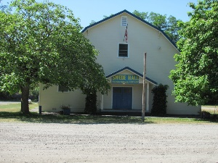
Preserving Swede Hall and Promoting Community Involvement
MEMBERSHIP APPLICATION
Name
Address
Phone number
Email Address
Signature

Yearly dues: $15.00 Make checks payable to RCG
Please provide an interest you have in assisting with Swede Hall maintenance, upkeep, or suggestion for fundraising.
______________________________________________________________________________________________________________________________________
********************************************************************************
To be filled out by Treasurer

Rec’d by_____________________________________ Date____________
Membership # ________________________________

